

Data Room
Deck
FAQ doc (really helpful)

Opportunity
$4M priced seed round – two soft commits secured, wants to close by end of April
Architect Health is raising a Seed round to unlock $9.2M+ in converted contract value.
Use of funds - Scale product and engineering and build fully commercially viable product with agentic AI system
Founders Sohum Shah and Sidd Hariharan bring deep payer + digital health experience from Humana, BCBSM, and Oliver Wyman.
“I hope you are doing well and congrats on the new funds close! Exciting news from us as well - given recent payer pilot traction and investor interest, we're officially kicking off our Seed fundraise, ahead of schedule. We're running a tight process, with several soft commits already in, and are looking to partner with early-stage investors that are actively deploying at the intersection of healthcare x AI. If interested, please let me know what your best availability looks like to connect. If convenient, feel free to find time on my calendar here.”

Company Overview
Payers spend $9M+ annually on manual vendor procurement processes that are slow, fragmented, and riddled with inefficiencies. Architect Health is building the modern vendor management system for payers, centralizing and automating sourcing, evaluation, and performance monitoring. Their wedge is telehealth, where vendor fragmentation is most acute—with over 330+ point solutions contributing to fatigue and inefficiency.
Architect aims to become the vendor procurement engine for all of healthcare, expanding from telehealth into billing, member services, and analytics.]
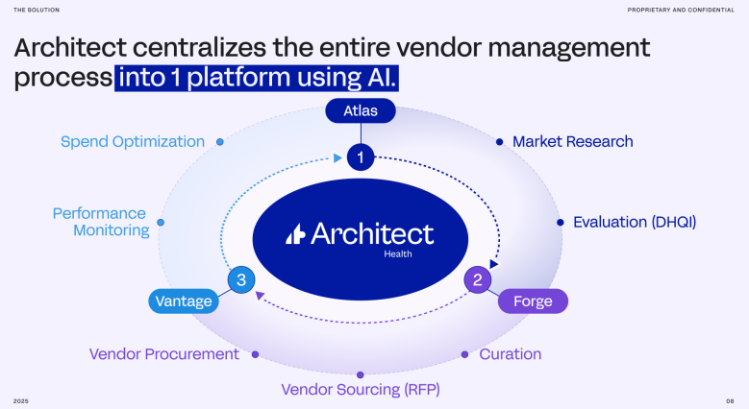
Architect Health offers an AI-powered vendor management platform that reduces the 12–36 month procurement slog to weeks. The product includes:
- Atlas – AI-driven vendor insights and evaluations (clinical efficacy, reliability, equity)
- Forge – Automated, intelligent RFP generation and scoring
- Vantage – ROI analysis and cost-optimization of vendor portfolios
Key metrics & traction:
- 5 payer pilots, with 3 signed in the last month
- $1.1M+ in cost savings for a small Texas payer (via MSK vendor curation)
- 92% reduction in procurement cycle time
- $9.2M+ in cumulative contract value from existing LOIs
- 32 payers in pipeline, representing a $12B opportunity
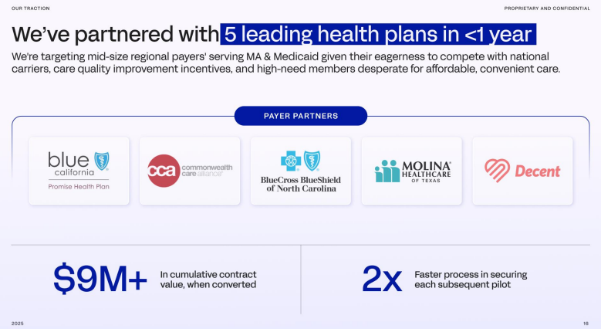
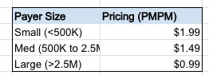

Workplan / Next Steps
- RS and ABG met on 3/26 notes in Affinity (+ transcript)
- Robby met on 4/18 notes in Affinity
- Robby intro’d ABG and RS to Brett Rosen for follow up
- Robby intro’d to:
  - Jeff Plante Done
  - Molly Loftus
  - Sequoia Lesley
- Backchannel with payers in our network?
- Reference w existing investors
  - Healthworx
  - Plug & Play
- Tech diligence / security overview w David
- Robby spend time with Sid in Chicago

What Do We Need to Believe
- Payers will adopt a centralized vendor management platform and displace internal/consultant-led procurement
- AI-based scoring and analytics will be trusted for high-stakes vendor selection.
- The platform will remain differentiated as competitors build or pivot into adjacent areas
- Can convert pilot customers into real contracts

Follow-Up Questions
Product
- Walk us through the implementation and onboarding process? What systems do you have to plug into to deliver ROI for customers?
- Have you encountered any challenges ingesting and cleaning payer data?
- Please provide a product roadmap
- What additional features are necessary to expand to the “growth pricing” shown in the market size analysis?
Financials / Pipeline
- In the pipeline does “contract fidelity” represent the likelihood of closing?
  - Do you have expected close dates for the 100% fidelity contracts?
- Noticed the pipeline shows avg. Price per seat of $15k for brokers but financial model has $22k – what's the difference?
- Is there no difference in pricing if the customer is only using one of the three products?
- Do you expect contracts to start at the “Standard ARR” in the pipeline or is there a land and expand motion required?
Sales
- What is your GTM strategy currently? How did you meet your pilot customers?
- Who is the buyer internally and do you sell into an existing line item?
- What has sales cycle been to date
- How do you think about CAC and LTV?
- How do pilot customers measure success / what do they expect to see before converting to contracts?
Strategy / Vision
- What is your hiring plan after this round?
- Walk us through your long-term vision for Architect, how do you get to $100M in revenue?
- How do you think about maintaining defensibility?

Blurb for Network
Architect Health is the AI-powered vendor management system transforming how payers source and manage vendors—starting with telehealth. The team has piloted with 5 payers covering nearly 7M lives, saved one payer over $1.1M, and shortened procurement cycles by 92%. Their wedge is telehealth, but the vision is broader: Architect is building the vendor procurement engine for all of healthcare. Backed by top healthcare leaders and raising a Seed to unlock $9M+ in contract value.

Reference Notes
Brett Rosen
“Hi Robby, I hope this note finds you well. I have been testing Architect Health with some of the top brokers in the country and it is exceptionally well received. I’d love your feedback and happy to kick this one around if it would be helpful!

